**DEPARTMENT OF INFORMATION TECHNOLOGY**

**COURSE CODE:DJS22ITL503 DATE: 06-08-2024**

**COURSE NAME:Data Warehousing and Mining CLASS:T Y B.TECH**

**LAB EXPERIMENT NO.01**

**CO/LO: To visualize the data for a data warehouse using the business intelligence tool**

**AIM / OBJECTIVE: To create business intelligent reports using Tableau**

**DESCRIPTION OF EXPERIMENT:**

The experiment involves using Tableau to create Business Intelligence Reports by importing the Sample Superstore dataset. Students will learn to visualize data through maps, dashboards, and stories.

**INPUT DATA / DATASET:**

Data Visualisation with Tableau/Sample-Superstore .xls

**PROCEDURE / ALGORITHM:**

**TECHNOLOGY STACK USED:**

**SOURCE CODE (OPTIONAL):**

**OBSERVATIONS / DISCUSSION OF RESULT:**

1. Display the total aggregated sales for each year by order date.

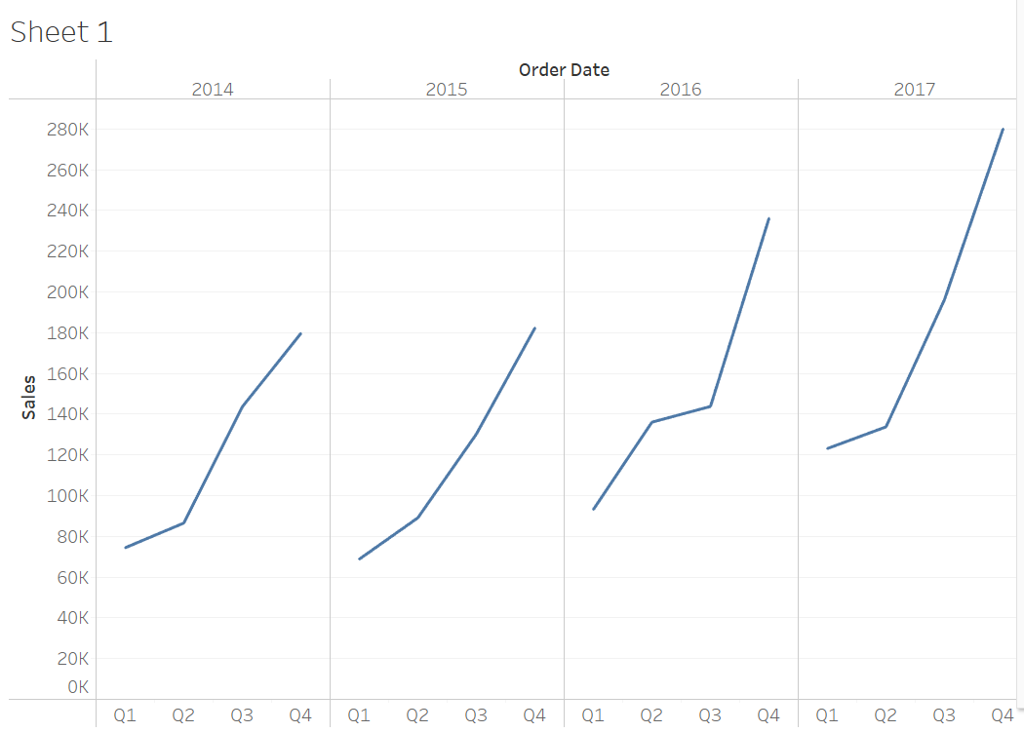

1. Display Sales in different Time period (Quarter, Month, Day)

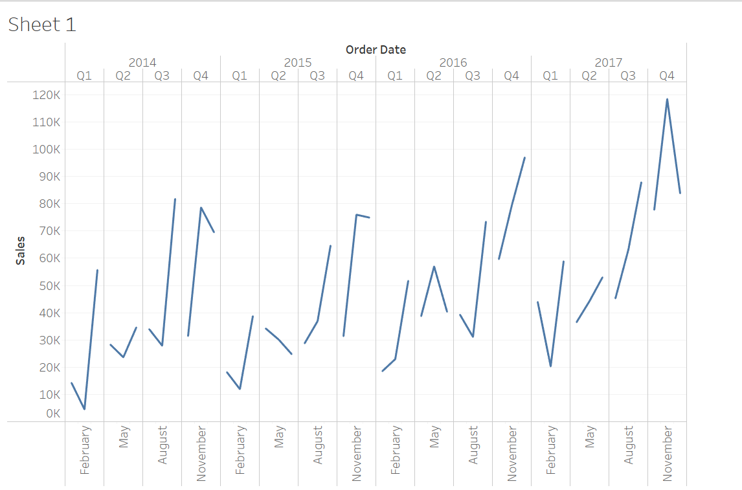

1. Find out more insights regarding which products drive more sales.
   1. Show marked labels
   2. Sort sum of sales descending/ascending within category
   3. Swap the orientation of the chart

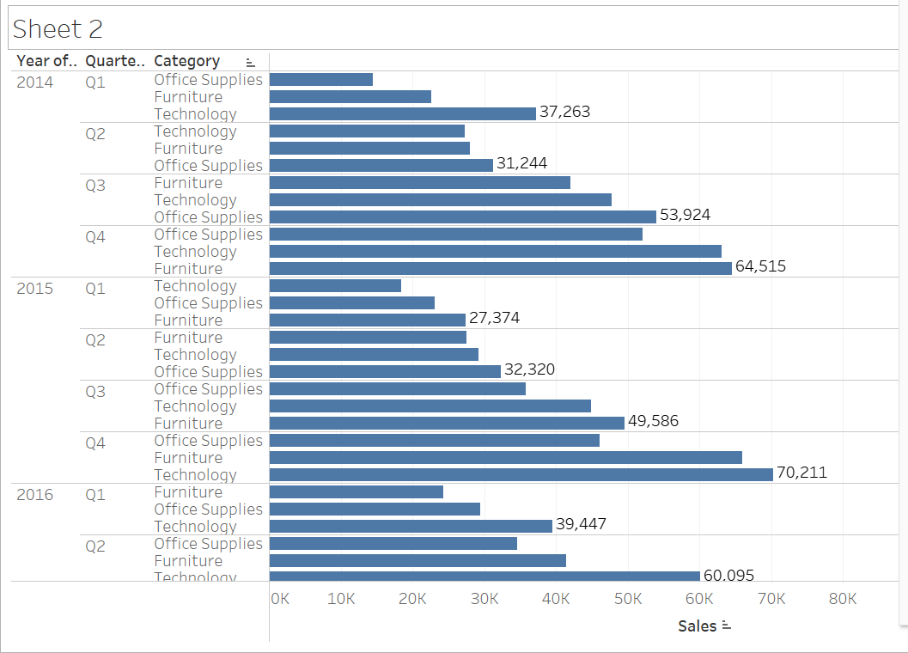

1. Look at products by Sub-category to see which items are the big sellers.

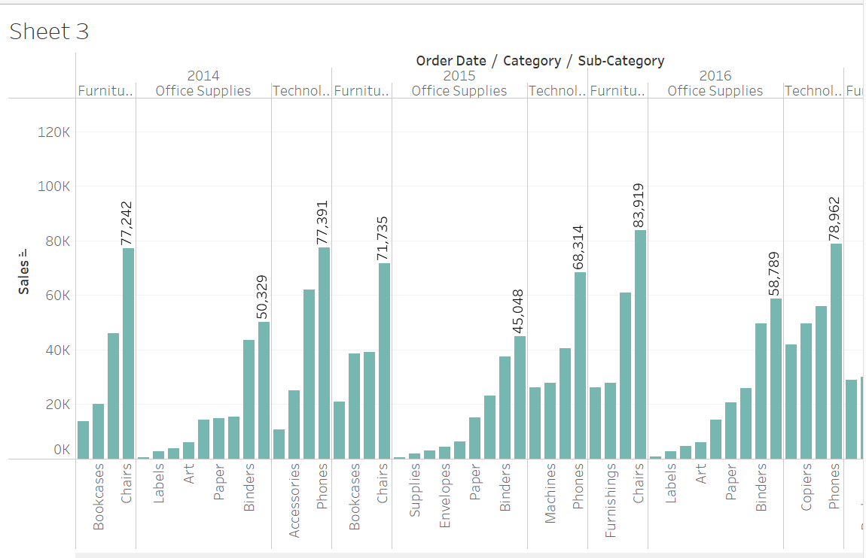

1. Apply filter to order date for category and sub category.

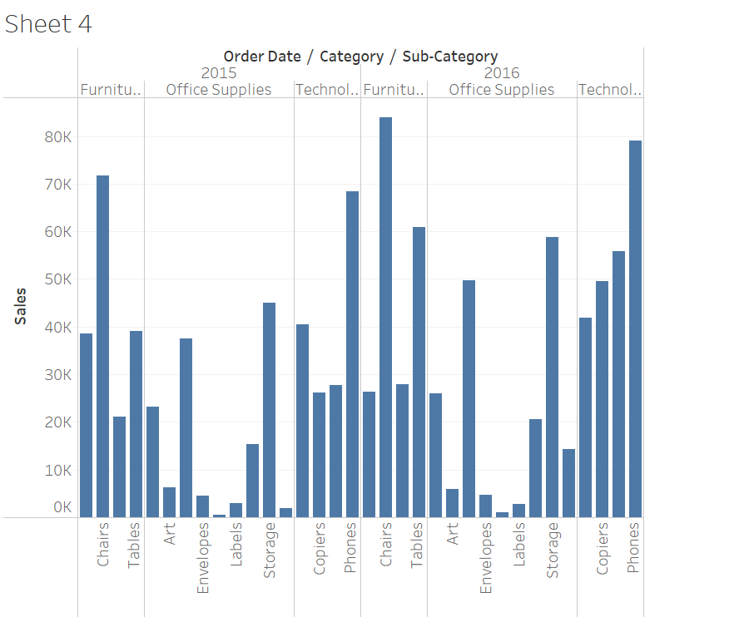

1. Visualize the profit using the colors.

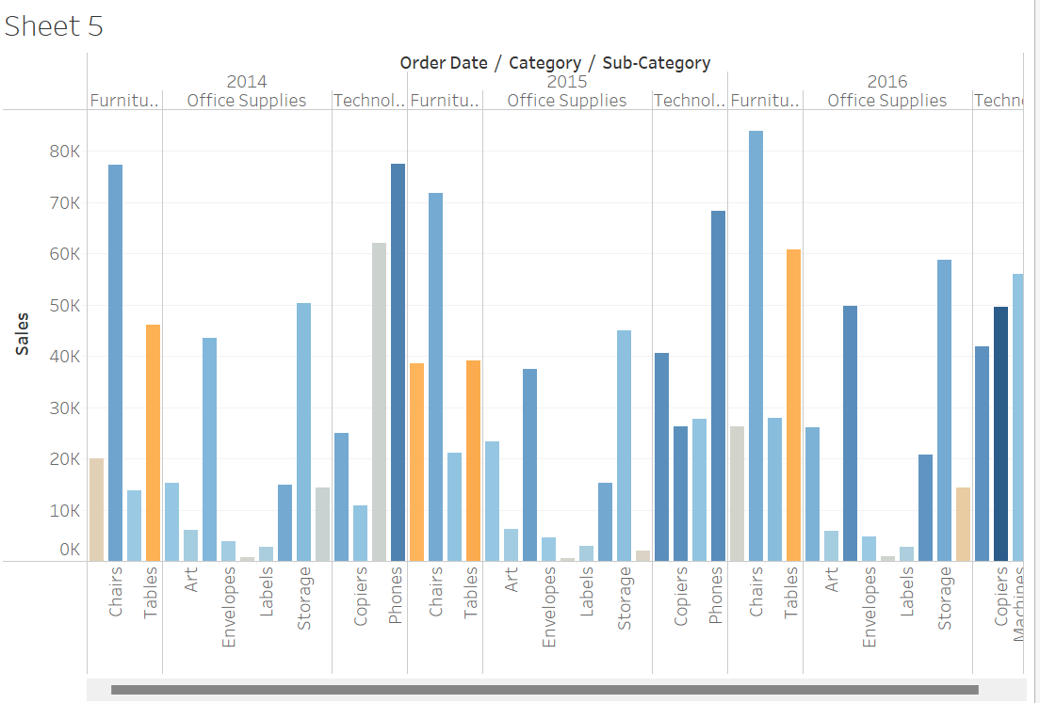

1. Drag Region to the Rows shelf and place it to the left of the Sum(Sales).
2. At the bottom-left of the workspace, double-click Sheet 1 and type Sales by Product and Region sheet and select Duplicate and rename the duplicated sheet to Sales-South.
3. In the new worksheet, from Dimensions, drag Region to the Filters shelf to add it as a filter in the view.
4. In the Filter Region dialogue box, clear all check boxes except South and then click OK. Now we can focus on sales and profit in the South.

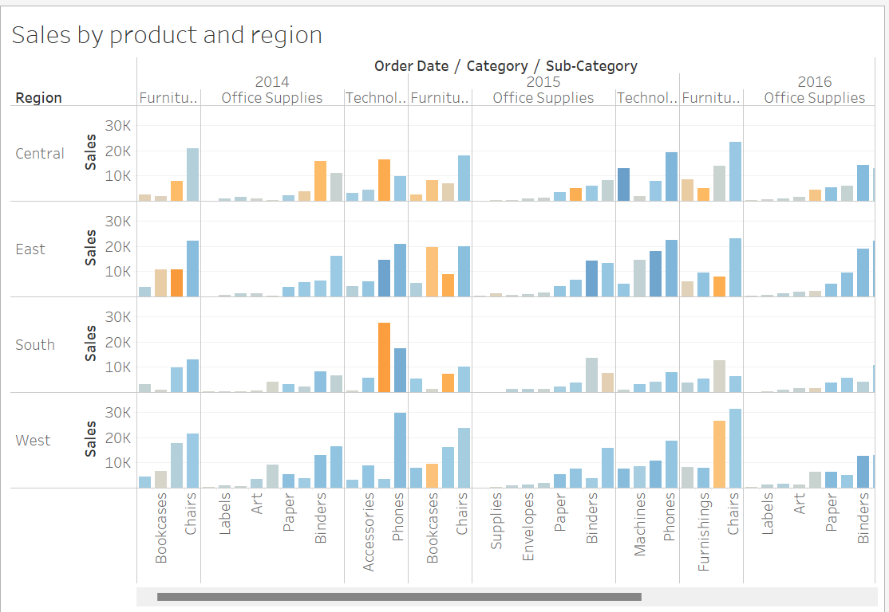

Creating a Map View

1. Create a new worksheet.
2. Add State and Country under Data pane to Detail on the Marks card. We obtain the map view.
3. Drag Region to the Filters shelf, and then filter down to South only. The map view now zooms in to the South region only, and a mark represents each state.
4. Drag the Sales measure to the Color tab on the Marks card. We obtain a filled map with the colors showing the range of sales in each state.
5. We can change the color scheme by clicking Color on the Marks card and selecting Edit Colors.

Write Observations for Florida Sales:

1. Display the performance by Profit.
2. Drag Profit to Color on the Marks card. Rename the sheet as Profit Map.

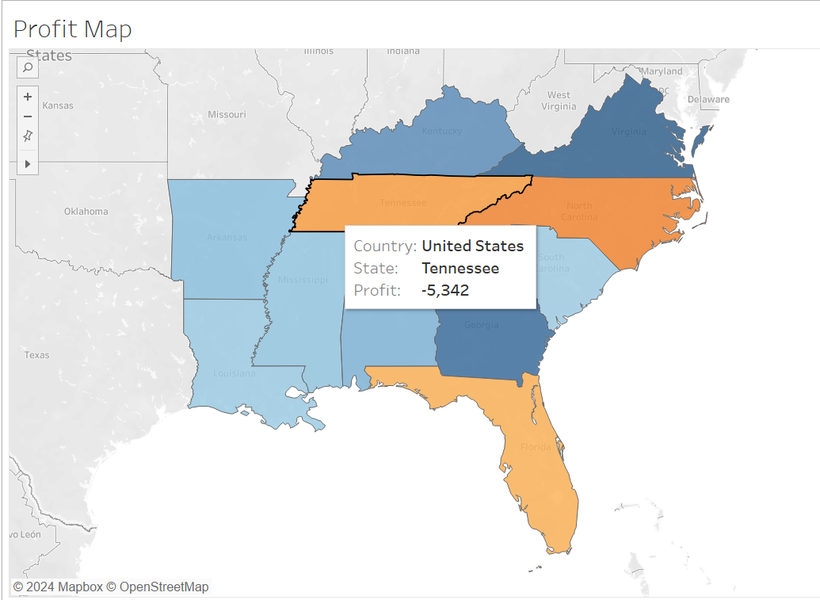

Write Observations for Florida Profit:

1. Duplicate the Profit Map worksheet and name it Negative Profit Bar Chart.
2. Click Show Me on the Negative Profit Bar Chart worksheet. Show Me presents the number of ways in which a graph can be plotted between items mentioned in the worksheet. From Show Me select the horizontal bar option and the view updates to horizontal from vertical bars instantly.

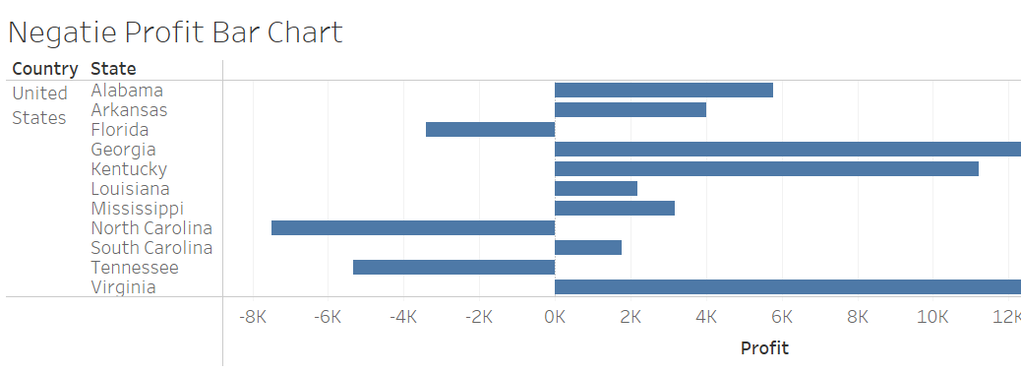

Creating Hierarchies

Hierarchies come in handy when we want to group similar fields so that we can quickly drill down between levels in the viz.

1. In the Data pane, drag a field and drop it directly on top of another field or right-click the field and select
2. Drag any additional fields into the hierarchy. Fields can also be re-ordered in the hierarchy by simply dragging them to a new position. Create the following hierarchies: Location, Order, and Product.

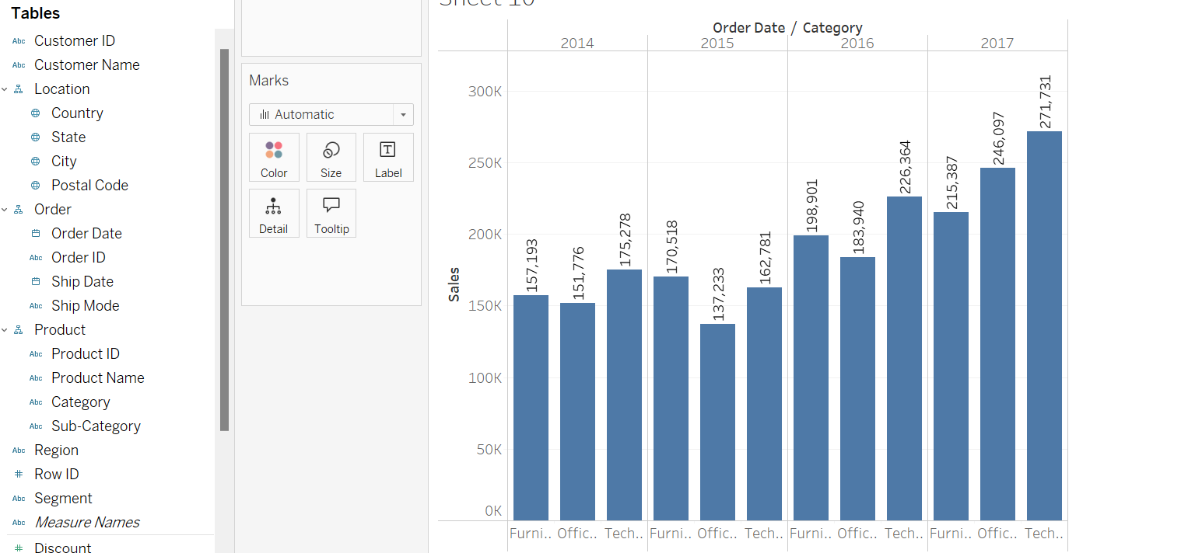

Creating a Dashboard

1. Click the New dashboard button.
2. Drag Sales in the South to the empty dashboard
3. Drag Profit Map to the dashboard and drop it on top of the Sales in the South view. Both views can be seen at once. To be able to present data in a manner so that others can understand it we can arrange the dashboard to our liking.
4. Start with the Profit Map. On clicking the map, a Use as filter icon appears in the upper right. Click on it. If we select any map, Sales corresponding to that state will be highlighted in the Sales-South map.
5. For the Year of Order Date, click on the drop-down option and go to Apply to Worksheets > Selected Worksheets. A dialog box opens up. Select the All option followed by OK. What does this option do? It applies filters to all the worksheets having the same data source.
6. Explore and experiment. In the visualization below, we can filter the Sales South map to view products that are being sold in North Carolina only. We can then easily explore the profits yearly.
7. Rename the Dashboard to Regional Sales and Profit.

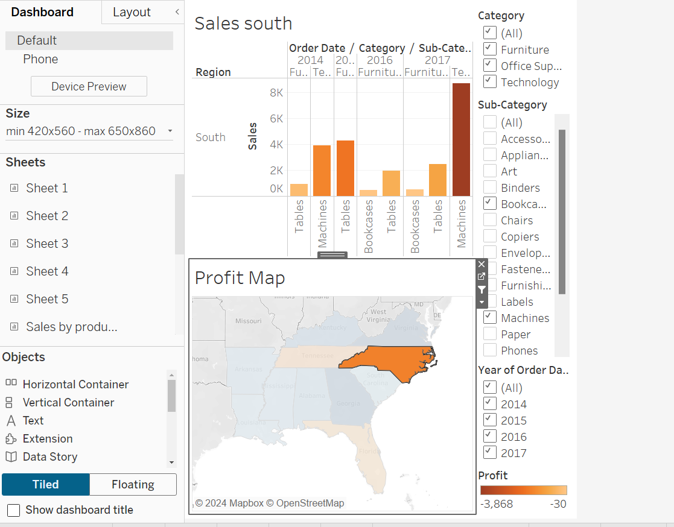

Create a story

1. Click the New story button.
2. From the Story pane on the left, drag the Sales in the South worksheet (created earlier) onto the view.
3. Edit the text in the gray box above the worksheet. This is the caption. Name it as Sales and profit by year.
4. Stories are quite specific. Here we will tell a story about selling machines in North Carolina. In the Story pane, click on Duplicate to duplicate the first caption, or you may even create a new one.
5. In the Sub-Category, filter select only Machines. This helps to gauge sales and profit of machines by year.
6. Rename the caption to Machine sales and profit by year.

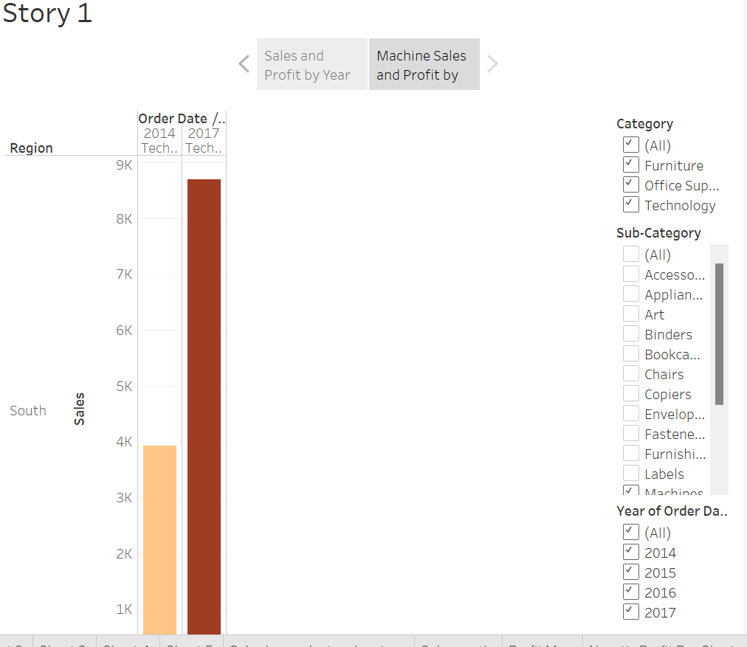

**CONCLUSION:**

In conclusion, this experiment emphasizes the importance of data visualization using Tableau, enabling users to create insightful business intelligence reports.

**REFERENCES:**

[1] Ponniah P., “Data Warehousing: Fundamentals for IT Professionals”, 2nd Edition, Wiley India, 2013.  ​

[2] Ageed, Z. S., Zeebaree, S. R., Sadeeq, M. M., Kak, S. F., Yahia, H. S., Mahmood, M. R., & Ibrahim, I. M. (2021), “Comprehensive survey of big data mining approaches in cloud systems”, Qubahan Academic Journal, 1(2), 29-38.

**​Website References:​**

Mota, R. (2021, May 31). Data visualization in Tableau. DataCamp. Retrieved August 4, 2024, from https://www.datacamp.com/tutorial/data-visualisation-tableau